Neighborhood Notification: Bicycle Improvements on
95th Ave/Windrow Blvd from Broadway Rd to Riverwood Blvd
As part of the Street Transportation Department’s core mission, we strive to improve the City’s roadways to create a safe and efficient transportation network. Our ongoing review of street design provides opportunities to change the current traffic lane striping to improve safety for people who walk, drive, ride bicycles and use transit.
About the Project
Where: 95th Avenue / Windrow Boulevard from Broadway Road to Riverwood Boulevard
What: Where there is enough space on the roadway, buffered bike lanes will be added. The number of travel lanes will remain the same. On-street parking will be removed from both sides of the street between Broadway Rd and 95th Avenue.
When: Traffic lane improvements are planned for Winter 2026.
Why: Buffered bike lanes add space between people driving and people walking or biking for increased protection from vehicles, improved safety and added comfort. Additionally, the slight narrowing of the lane widths to accommodate the buffered bike lanes will help to guide cars and deter speeding.
What will the Project Look Like?

Current Travel Lanes
Broadway Rd to 95th Ave 95th Ave to Riverwood Blvd
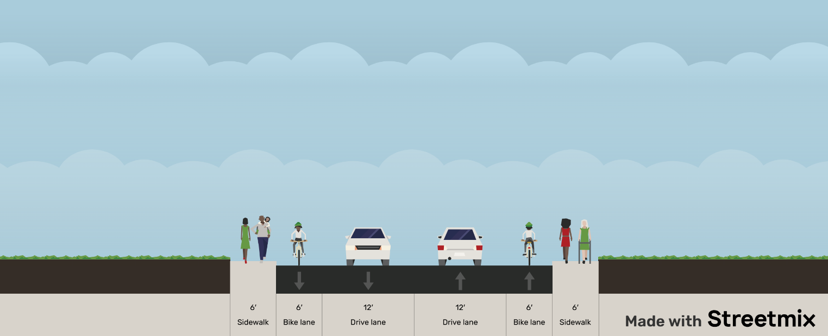
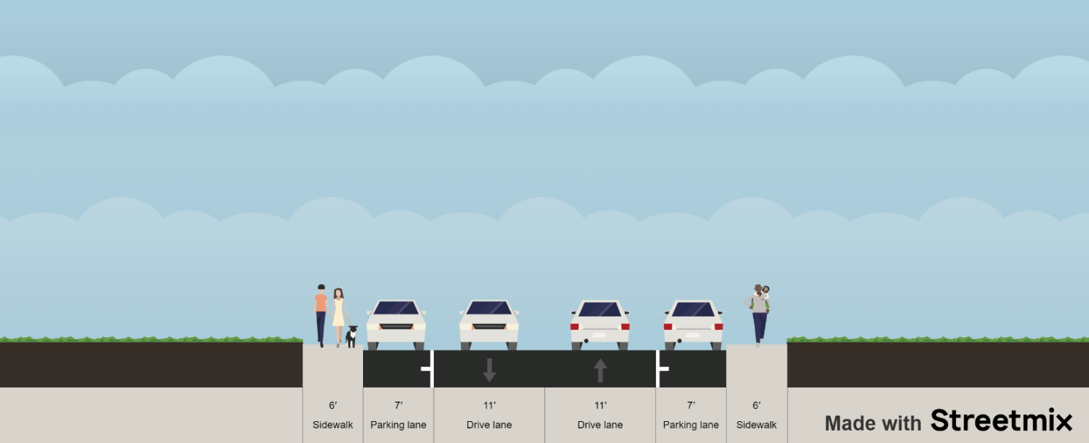

(Parking allowed, both sides) (No parking allowed, both sides)
Modified Travel Lanes

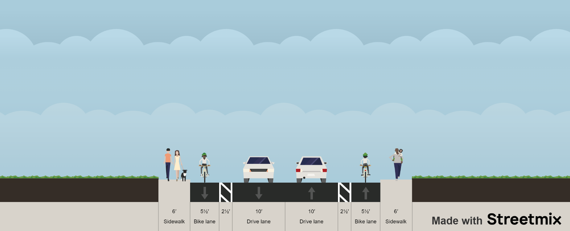
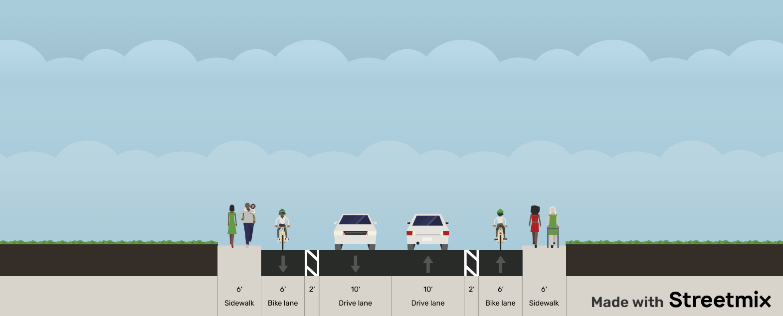
Broadway Rd to 95th Ave 95th Ave to Riverwood Blvd

Questions, Comments or Concerns?
We welcome and value your questions and input. If you have any questions or need additional information, please reach out to the following contacts.

City of Phoenix Active Transportation Program City of Phoenix Pavement Maintenance Program
Phone: 602-534-0258 Phone: 623-825-3444
Email: bike@phoenix.gov Email: pavement@phoenix.gov
phoenix.gov/bicycling phoenix.gov/pavementprogram

