Neighborhood Notification: Bicycle Improvements on
12th Street from Liberty Lane to Marketplace Way SE
As part of the Street Transportation Department’s core mission, we strive to improve the City’s roadways to create a safe and efficient transportation network. Our ongoing review of street design provides opportunities to change the current traffic lane striping to improve safety for people who walk, drive, ride bicycles and use transit.
About the Project
Where: 12th Street from Liberty Lane to Marketplace Way SE
What: Where there is enough space on the roadway, buffered bike lanes will be added. The number of travel lanes will remain the same. On-street parking will be removed from both sides of the street.
When: Traffic lane improvements are planned for Winter 2026.
Why: Buffered bike lanes add space between people driving and people walking or biking for increased protection from vehicles, improved safety and added comfort. Additionally, the slight narrowing of the lane widths to accommodate the buffered bike lanes will help to guide cars and deter speeding.
What will the Project Look Like?

Current Travel Lanes
Liberty Lane to Marketplace Way Southeast
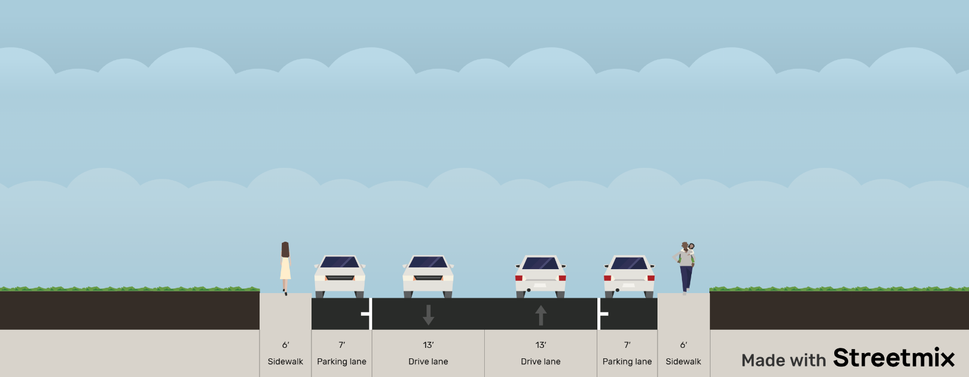

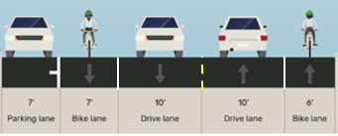
(Parking allowed, both sides)
Proposed Travel Lanes
700 Feet North of Liberty Lane to
Liberty Lane to 700 Feet North Marketplace Way Southeast
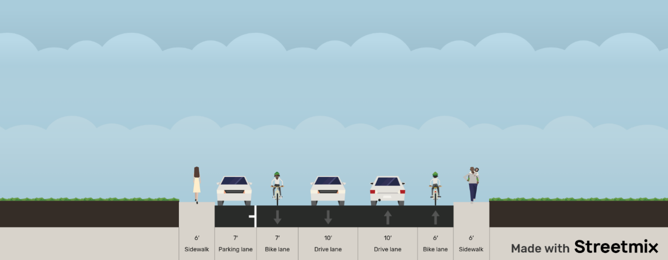
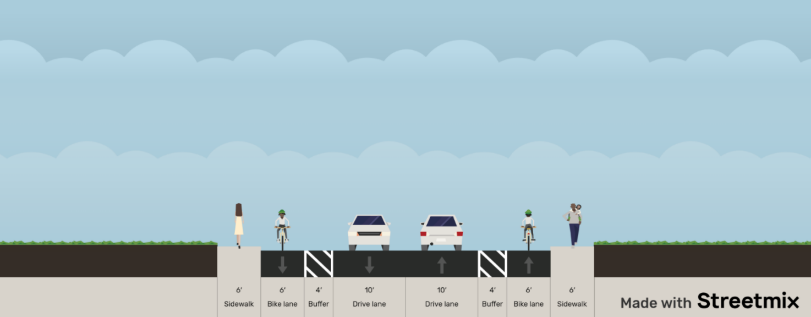

(Parking preserved on west side near the school)
Questions, Comments or Concerns?
We welcome and value your questions and input. If you have any questions or need additional information, please reach out to the following contacts.

City of Phoenix Active Transportation Program City of Phoenix Pavement Maintenance Program
Phone: 602-534-0258 Phone: 623-825-3444
Email: bike@phoenix.gov Email: pavement@phoenix.gov
phoenix.gov/bicycling phoenix.gov/pavementprogram

